Mathematics Specialist Investigations

Year 12

Topic 3.3: Vectors in three dimensions

Authors: Rom Cirillo
Margaret Denham
Romaine Saunders
Amy Shaw
Ed Taylor

Editors: Rom Cirillo
Romaine Saunders

For each topic three types of tasks are included:
- Extended investigation – an investigation which could be done in the student’s own time followed by an in-class validation. Solutions are provided where practicable for the preparation activity/investigation. For the in-class validation, there are solutions and marking keys which identify the mathematical behaviours that students may exhibit.
- In-class investigation – an investigation for which no prior preparation is required. Solutions and marking keys are provided.
- Investigative questions – a series of short questions which test the student’s ability to apply their learning, to justify their conclusions, to investigate and to generalise, or to solve problems. Such questions could be included in a response or examination assessment. Solutions and marking key are provided.

Screen shot have been produced using the CASIO ClassPad II emulator or the ti-nspire CAS emulator.

Most graphs and diagrams have been produced using efofex software.

© The investigations and solutions in this publication are for the sole use of staff and students of the purchasing school. It is a breach of copyright to distribute them in whole or part in any form now or in the future to any other school, company or person.

Contents:
MATHEMATICS SPECIALIST: Year 12

3.1 Complex numbers
Task 1: Extended investigation: The Factor and Remainder Theorems
Task 2: In-class investigation: Complex numbers using e^{iθ}
Task 3: Investigative questions

3.2 Functions and sketching graphs
Task 4: Extended investigation: The graphs of rational functions
Task 5: In-class investigation: The absolute value function
Task 6: Investigative questions

3.3 Vectors in three dimensions
Task7: Extended investigation: Systems of equations
Task 8: In-class investigation: Cross product
Task 9: Investigative questions

4.1 Integration and applications of integration
Task10: Extended investigation: The Golden Gate bridge
Task 11: In-class investigation: Which sculpture
Task 12: Investigative questions

4.2 Rates of change and differential equations
Task13: Extended investigation: Time of death
Task 14: In-class investigation: The logistic function
Task 15: Investigative questions

4.3 Statistical inference
Task16: Extended investigation: TBA
Task 17: In-class investigation: TBA
Task 18: Investigative questions

This package only contains the investigations associated with topic 3.3: Vectors in three dimensions

If your school has purchased the complete set of 18 investigations, you will be informed when the rest are ready for delivery/download.

TASK 7: SOLVING 3x3 SYSTEMS OF LINEAR EQUATIONS

Extended Investigation

Unit 3

Topic 3.3: Vectors in three dimensions

Course-related information
The skills and concepts developed in this extended investigation relate to the following dot points within the WA Mathematics Specialist syllabus.
3.3.9 recognise the general form of a system of linear equations in several variables, and use elementary techniques of elimination to solve a system of linear equations
3.3.10 examine the three cases for solutions of systems of equations - a unique solution, no solution, and infinitely many solutions - and the geometric interpretation of a solution of a system of equations with three variables

This task provides opportunities for students to use matrices to solve 3x3 systems of linear equations using the Row Reduction Method, also known as the Gaussian elimination method, and to use a CAS calculator to check their answers.

The students are asked to apply reasoning skills and to communicate their solutions, including the geometric interpretation of the solutions.

Background Information
Students are assumed to have successfully completed Mathematics Specialist Topic 2.2: Matrices, to be familiar with Cartesian coordinates for three dimensional space, the Cartesian equation of a plane and with using elementary techniques of elimination to solve a system of two linear equations.

Task Conditions
Students are expected to complete the preparation activity before the in-class validation. The preparation activity assumes that students will have access to CAS calculators. It is expected that students will not have access to calculators for the in-class validation. No student notes are required.

SOLVING 3X3 SYSTEMS OF LINEAR EQUATIONS

Extended Investigation Part 1: Preparation activity
The row reduction method, which is also known as the Gaussian elimination method, is a matrix method for solving systems of linear equations. The method is named after the German mathematician Carl Friedrich Gauss (1777-1855).

The row reduction method uses a sequence of elementary row operations to modify the matrix until the lower left-hand corner of the matrix is filled with zeros.

The three types of elementary row operations are:
Type 1: Interchanging two rows.
Type 2: Multiplying a row by a non-zero constant.
Type 3: Adding a constant multiple of one row to another row.

In each row of a matrix, the left-most non-zero entry is called the pivot of that row. For example, in the matrix below, -3 is the pivot of the first row, 7 is the pivot of the second row and 5 is the pivot of the third row.

The following three examples illustrate the use of this method to solve systems of linear equations.

Example 1: Solve the system of equations using the row reduction method.

Step 1: Write the system of equations in augmented matrix form. This is achieved by writing the coefficient matrix with an additional column for the constants on the right of the equal signs. The new column is set apart by a vertical line.

Step 2: Row reduce the augmented matrix.

Perform two row operations, both involving the first row, to obtain zeros in the first column beneath the pivot in the first row.

Perform one row operation involving the second and third rows to obtain zero beneath the pivot in the second row.

The symbols used above represent the row operations that have been used:
Subtract twice Row 1 from the old Row 2 to determine the elements in the new Row 2.
Add three times Row 1 to the old Row 3 to determine the elements in the new Row 3.
Add seven times Row 2 to five times Row 3 to determine the elements in the new Row 3.

Step 3: Rewrite the system using the row reduced matrix.

Step 4: Solve the resulting system of equations.
From equation (3),
Find by substituting into equation (2),
Find by substituting , into equation (3),
A unique solution,

Check solution using CAS calculator:
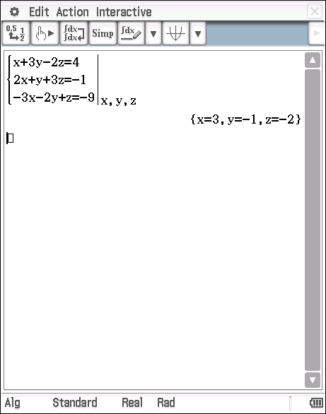

Geometrical Interpretation:
Three planes intersect at the point (3,-1,-2).

Example 2: Solve the system of equations using the row reduction method.

Step 1: Write the system of equations in augmented matrix form.

Step 2: Row reduce the augmented matrix.

Step 3: Rewrite the system using the row reduced matrix.

Step 4: Solve the resulting system of equations.

is a contradiction
Hence, this system has no solution

Check solution using CAS calculator:
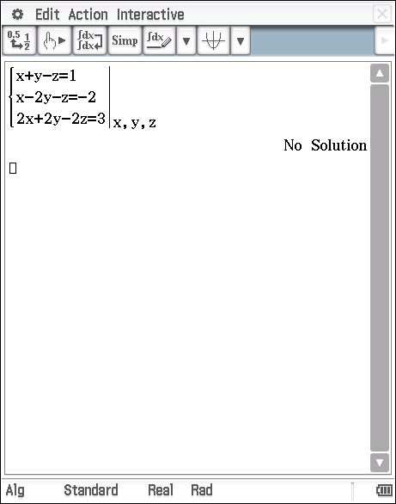

Geometrical Interpretation:
Intersection of two parallel planes, and , with a third plane.

Example 3: Solve the system of equations using the row reduction method.

Step 1: Write the system of equations in augmented matrix form.

Step 2: Row reduce the augmented matrix.

Step 3: Rewrite the system using the row reduced matrix.

Step 4: Solve the resulting system of equations.

is true
There is insufficient information to determine a unique set of solutions.
Hence, this system has an infinite number of solutions of the form

Check solution using CAS calculator:
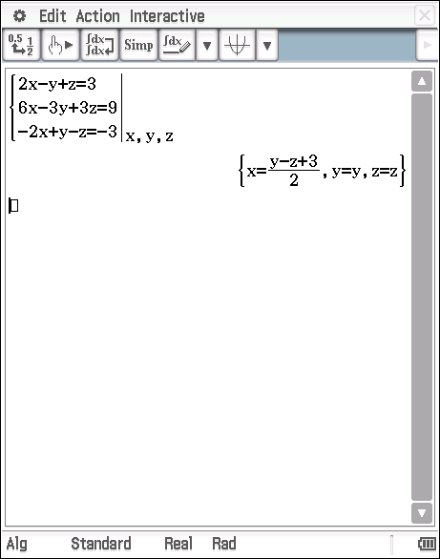

Geometrical Interpretation:
The three planes are coincident.

NOTE: There are two commands that may be used on the CAS calculator to solve a system of linear equation.

The “rref()” command (reduced row echelon form):
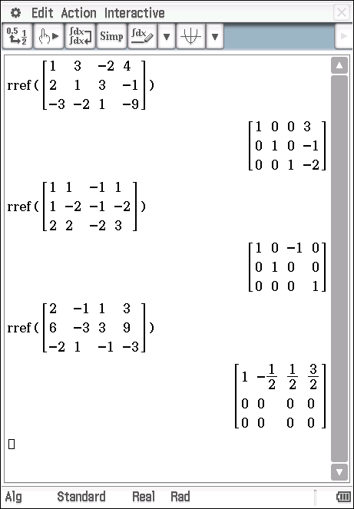

The “solve()” command:
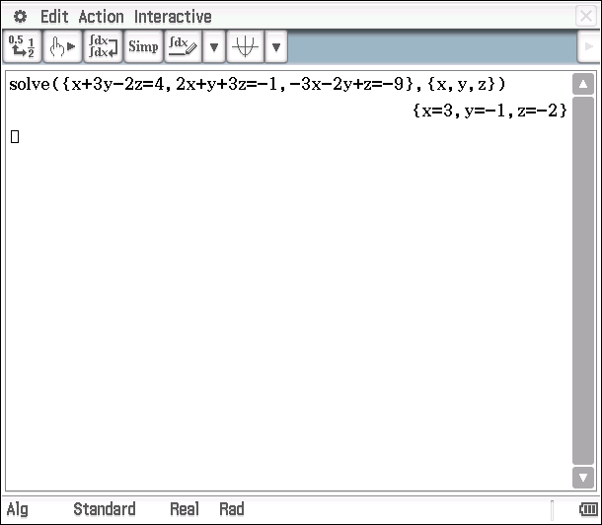

Solve the following 3x3 systems of equations using the row reduction method. Check your solutions using a CAS calculator and give a geometrical interpretation of each solution.

Question 1

Question 2

Question 3

Question 4

Note: Interchange the first and second rows to ensure that the element in the first row and first column, the pivot, is non-zero. The symbol represents rows 1 and 2 have been interchanged.

SOLVING 3x3 SYSTEMS OF LINEAR EQUATIONS

Extended Investigation Part 1: Preparation activity
Solutions
Question 1

From equation (3),
From equation (2),
From equation (3),

A unique solution,

CAS Calculator check:
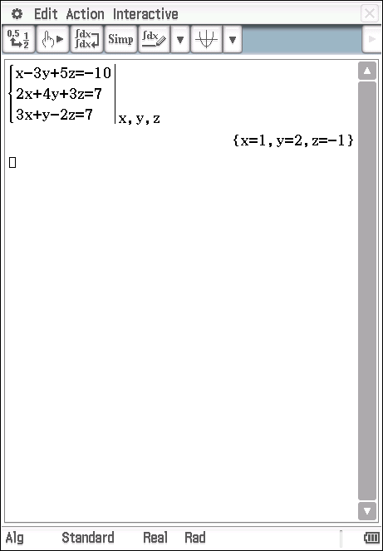

Geometrical Interpretation: The three planes intersect at the point (1,2,-1).

Question 2

is a contradiction
Hence, this system has no solution

CAS Calculator check
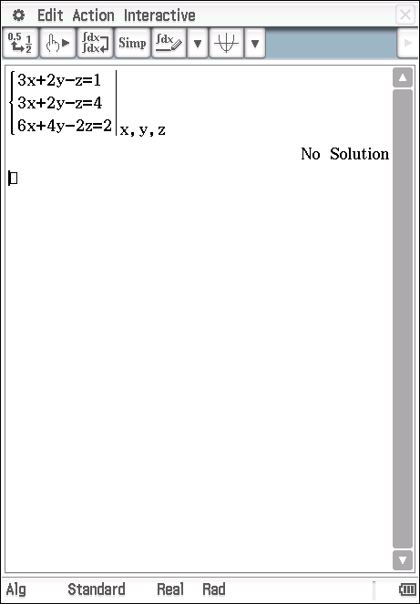

Geometrical Interpretation: Two planes are coincident and are parallel to the third plane.

Question 3

is true
There is insufficient information to determine a unique set of solutions.
Hence, this system has an infinite number of solutions of the form

Check solution using CAS calculator:
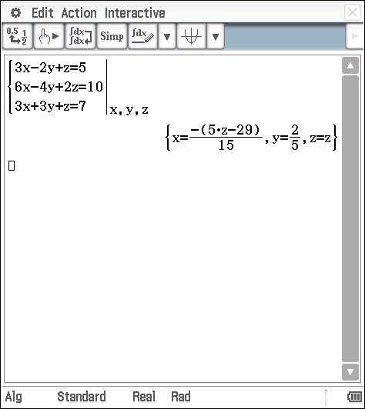

Geometrical Interpretation: Two planes are coincident and meet the third plane along a common line.

Question 4

From equation (3),
From equation (2),
From equation (3),

A unique solution,
Check solution using CAS calculator:
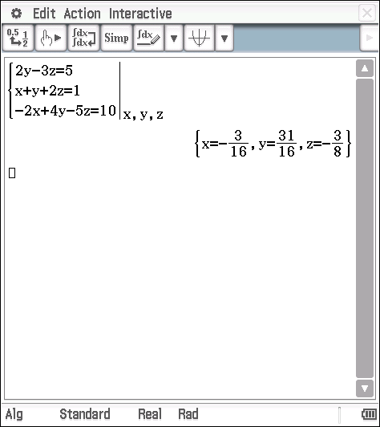

Geometrical Interpretation: The three planes intersect at the point .

SOLVING 3x3 SYSTEMS OF LINEAR EQUATIONS

Extended Investigation Part 2: In-class validation Part 2: In-class validation
Question 1 (5 marks)
For each of the row reduced augmented matrices with variables shown below, determine whether the 3x3 system of equations has
(i) a unique solution
(ii) no solution
(iii) an infinite number of solutions

Find the solution(s) to the system, if they exist.

(a)

(b)

(c)

Question 2 (17 marks)
Solve each of the following systems of equations using the row reduction method and interpret your solution geometrically.

(a) (5)

(b) (6)

(c) (6)

Question 3 (12 marks)
Consider the system of equations

(a) Determine the possible values of and if the system of equations has:
(9)
(i) a unique solution

(ii) no solution

(iii) an infinite number of solutions.

(b) Find the solution in (i) if . (3)

SOLVING 3x3 SYSTEMS OF LINEAR EQUATIONS

Extended Investigation Part 2: In-class validation
Solutions and marking key

Question 1(a)
Solution

A unique solution
Mathematical behaviours | Marks
- identifies unique solution  - correct values for | 1  1

Question 1(b)
Solution

Infinite solutions
Mathematical behaviours | Marks
- identifies infinite solutions  - correct values for | 1  1

Question 1(c)
Solution

No solution
Mathematical behaviours | Marks
- identifies no solution | 1

Question 2(a)
Solution

is a contradiction
Hence, the system has no solution.

Geometric interpretation: Three non-parallel planes that meet to form a prism.

Mathematical behaviours | Marks
- Applies row reduction to position zeros in the first column  - Applies row reduction to position a zero in the third row of the second column  - Correctly concludes the system has no solution  - Correct geometric interpretation | 2  1  1  1

Question 2(b)
Solution

is true.
There is insufficient information to determine a unique set of solutions. Hence, this system has an infinite number of solutions of the form

Geometrical Interpretation: The three planes meet along a common line.

Mathematical behaviours | Marks
- Interchanges rows 1 and 2  - Applies row reduction to position a zero in the third row of the first column  - Applies row reduction to position a zero in the third row of the second column  - Correctly concludes the system has an infinite number of solutions  - Correctly identifies the form of the solutions  - Correct geometric interpretation | 1  1  1  1  1  1

Question 2(c)
Solution

From equation (3),
From equation (2),
From equation (3),

A unique solution,

Geometrical Interpretation: The three planes intersect at the point .

Mathematical behaviours | Marks
- Applies row reduction to position zeros in the first column  - Applies row reduction to position a zero in the third row of the second column  - Correctly concludes the system has a unique solution  - Correctly identifies the unique solution  - Correct geometric interpretation | 2  1  1  1  1

Question 3(a) (i)
Solution

For a unique solution,
Mathematical behaviours | Marks
- Applies row reduction to position zeros in the first column  - Applies row reduction to position a zero in the third row of the second column  - Correctly determines condition for a unique solution  - Correctly determines | 2  1  1  1

Question 3(a) (ii)
Solution
For no solution, and
Mathematical behaviours | Marks
- Correctly determines conditions for no solution  - Correctly determines | 1  1

Question 3(a) (iii)
Solution
For an infinite number of solutions, and
Mathematical behaviours | Marks
- Correctly determines conditions for an infinite number of solutions  - Correctly determines | 1  1

Question 3(b)
Solution
If , then
From equation (3),
From equation (2),
From equation (3),

A unique solution,

Mathematical behaviours | Marks
- Correctly determines  - Correctly determines  - Correctly determines | 1  1  1

TASK 8: THE CROSS PRODUCT

In–class Investigation

Unit 3

Topic 3.3 Vectors in three dimensions

Course-related information
The skills and concepts developed in this in-class investigation relate to the following dot points within the WA Mathematics Specialist syllabus.

3.3.7 use the cross product to determine a vector normal to a given plane

This task provides opportunities for students to develop an understanding of the Cross Product in component form and use the Cross Product in a variety of situations.

Background Information
Students are assumed to have successfully completed WA Mathematics Specialist Topic 1.2 Vectors in the Plane and 3.3.1 (review the concept of vectors from Unit 1 and extend to three dimensions including introducing the unit vectors ). It is also assumed that students will complete this in-class investigation before studying the cross product in class.

Task Conditions
For this task students should not have access to a CAS calculator. No student notes are required.

THE CROSS PRODUCT
In-class investigation
The scalar (dot) product provides a scalar result; however, the cross product of two vectors and , provides a vector result. The cross product is defined as where is the angle between the vectors and , is a unit vector perpendicular to both and such that , and form a right-handed system as shown in the diagram below.

Question 1 (4 marks)
Given the angle between and is , and is the unit vector perpendicular to vectors and as shown in the diagram below.

Determine:

(a) (2)

(b) (1)

(c) (1)
Question 2 (5 marks)
Given ,
(a) express in terms of . (2)

(b) Using the definition of the dot product, express in terms of . (1)

(c) Hence, express in terms of the components of vectors . Do not simplify your answer. (2)

It can be shown that the component form of is
.

A visual way to remember the component form for the cross product is shown below:

Alternatively, the 3 x 3 determinant form may be used to help remember the component for the cross product – it is technically not a determinant because not all of the entries of the corresponding matrix are real numbers.

If , then
Put in Row 3
Put in Row 2

Note the subtraction of the component.

Question 3 (16 marks)
Consider the vectors , and ,

(a) Find (2)

(b) Show that is perpendicular to (2)

(c) Determine (2)

(d) Determine (2)

(e) What can you conjecture about and ? (1)

(f) Prove your conjecture is always true. (5)

(g) What can you conclude about ? (2)

Question 4 (3 marks)
A plane contains the three points A, B and C with position vectors , , , respectively. Find a vector that is perpendicular to this plane.

Question 5 (7 marks)
(a) Show that the area of a parallelogram with sides and is . (3)

(b) Determine the exact area of the triangle with vertices at A(2,3,-5), B(0,2,-3) and C(3,0,-3). (4)

Question 6 (5 marks)
By considering the sides of a triangle to be where and taking the cross product of both sides with respectively, establish the law of sines for triangle ABC, i.e. .

THE CROSS PRODUCT

In-class investigation
Solutions and marking key

Question 1(a)
Solution
Mathematical behaviours | Marks
- Substitutes correctly into cross product formula  - Correct vector result | 1  1

Question 1(b)
Solution
Mathematical behaviours | Marks
- Correct vector result | 1

Question 1(c)
Solution
Mathematical behaviours | Marks
- Correct magnitude | 1

Question 2(a)
Solution
Mathematical behaviours | Marks
- Chooses Pythagorean identity  - Correct expression in terms of | 1  1

Question 2(b)
Solution
Using ,
Mathematical behaviours | Marks
- Correct expression in terms of | 1

Question 2(c)
Solution
Mathematical behaviours | Marks
- Applies component form of  - Correct expression in terms of components | 1  1

Question 3(a)
Solution
Mathematical behaviours | Marks
- Applies component form of cross product  - Correct answer | 1  1

Question 3(b)
Solution
Since and neither nor are the zero vector, then is perpendicular to .
Mathematical behaviours | Marks
- Shows that  - Correct conclusion | 1  1

Question 3(c)
Solution
Mathematical behaviours | Marks
- Determines  - Correct cross product | 1  1
Question 3(d)
Solution
Mathematical behaviours | Marks
- Calculates  - Calculates | 1  1

Question 3(e)
Solution
Since and ,
conjecture that
Mathematical behaviours | Marks
- Correct conjecture | 1

Question 3(f)
Solution
Let .
Mathematical behaviours | Marks
- Expresses in component form  - Expresses in component form  - Expresses in component form  - Rearranges component form  - Establishes | 1  1  1  1  1

Question 3(g)
Solution
Mathematical behaviours | Marks
- Recognises  - Establishes | 1  1

Question 4
Solution
Hence, is a vector perpendicular to the plane containing the three points A, B and C.
Mathematical behaviours | Marks
- Correctly determines  - Correctly determines  - Determines a vector perpendicular to the plane | 1  1  1

Question 5(a)
Solution
u
v
|v|
|u|
θ

Let be the angle between vectors .
Mathematical behaviours | Marks
- Expresses in terms of  - Applies correct formula for area of parallelogram  - Concludes area of parallelogram is | 1  1  1

Question 5(b)
Solution
Area of triangle = Area of parallelogram with adjacent sides .

Mathematical behaviours | Marks
- Establishes  - Correctly determines  - Correctly determines  - Correct area | 1  1  1  1

Question 6
Solution

In a similar manner, it can be shown that and hence, .

Mathematical behaviours | Marks
- Uses  - Uses  - Uses  - Applies definition of cross product  - Establishes sine rule | 1  1  1  1  1

TASK 9: INVESTIGATIVE QUESTIONS

Unit 3

Topic 3.3 Vectors in three dimensions

Course-related information
The concepts and skills included in these investigative questions relate to the following dot points within the WA Mathematics Specialist syllabus.

3.3.1 review the concept of vectors from Unit 1 and extend to three dimensions, including introducing the unit vectors
3.3.3 introduce Cartesian coordinates for three dimensional space, including plotting points and equations of spheres
3.3.5 determine a vector equation of a straight line and straight line segment, given the position of two points or equivalent information, in both two and three dimensions
3.3.6 examine the position of two particles, each described as a vector function of time, and determine if their paths cross or if the particles meet
3.3.7 use the cross product to determine a vector normal to a given plane
3.3.8 determine vector and Cartesian equations of a plane
3.3.11 consider position vectors as functions of time
3.3.13 differentiate and integrate a vector function with respect to time
3.3.15 apply vector calculus to motion in a plane, including projectile and circular motion

The ability to choose and use appropriate technology to enhance and extend concept development is also required for some of the items.

Background Information
Each of the questions provided is stand-alone and may be incorporated into different tasks: it is not intended that they form part of the same assessment task.

Task conditions
These questions are independent of each other and are written so that they may be incorporated into a test or examination. Student access to a graphical/CAS calculator is assumed. The time required to complete each question is left to the discretion of the teacher but the intention is that each question may be completed within 15 minutes.

Investigative questions for Topic 3.3

Question 1 (14 marks)
(a) Given vectors such that and , determine . (4)

(b) For vectors , the triple vector product is defined as .

For each of the following, determine whether the statement is true or false. Justify your answer.

(i) The triple vector product is a scalar. (2)

(ii) (4)

(iii) (4)

Question 2 (9 marks)
The planes and have equations and and normals respectively.

(a) Find, to the nearest degree, the acute angle between planes and . (3)

(b) Verify that line represented by the parametric equations
is the line of intersection of planes and . (2)

(c) Hence, find the vector equation of line . (1)

(d) Find . (1)

(e) Hence, explain the geometric relationship between line and . (2)

Question 3 (14 marks)
(a) A particle is projected from the ground with an initial speed of 140 ms⁻¹ at an angle of to the horizontal. Assume that the only force acting on the particle is the gravitational force and that acceleration due to gravity is 10 ms⁻².

(i) Find the maximum height of the projectile. (6)

(ii) Find the horizontal range of the projectile. (2)

(b) A missile is fired at a target from the edge of a 20m high building. The velocity of the missile seconds after firing is given by ms⁻¹ where are constants. At the instant that the missile is fired, a target moving with velocity passes directly overhead m above the base of the building. Show that for the missile to hit the target .

Take the base of the building as the origin. (6)

Investigative questions for Topic 3.3
Solutions and marking key

Question 1(a)
Solution
Solving (1) and (2) using CAS,
Mathematical behaviours | Marks
- Uses to obtain (1)  - Determines  - Uses to obtain (2)  - Solves system of equations to determine components of | 1  1  1  1

Question 1(b)(i)
Solution
False
is a vector and is a vector
Mathematical behaviours | Marks
- Concludes statement is false  - Justifies conclusion | 1  1

Question 1(b)(ii)
Solution
False

Mathematical behaviours | Marks
- Concludes statement is false  - Expands  - Applies  - Expands | 1  1  1  1

Question 1(b)(iii)
Solution
True

Mathematical behaviours | Marks
- Concludes statement is true  - Expands  - Expands  - Establishes | 1  1  1  1

Question 2(a)
Solution
Using CAS, to the nearest degree.
Mathematical behaviours | Marks
- Identifies  - Identifies  - Correct acute angle | 1  1  1

Question 2(b)
Solution
Substitute into and
Hence, line is the line of intersection of planes and
Mathematical behaviours | Marks
- Substitutes for into and  - Establishes line lies in both planes | 1  1

Question 2(c)
Solution
Mathematical behaviours | Marks
- Correct vector equation | 1

Question 2(d)
Solution
Mathematical behaviours | Marks
- Correct cross product | 1

Question 2(e)
Solution
Since , the line of intersection of the planes is parallel to .

Mathematical behaviours | Marks
- Identifies parallel vectors  - Correct conclusion | 1  1

Question 3(a)(i)
Solution
Max height reached when
Max height is
Mathematical behaviours | Marks
- Correct acceleration vector  - Correct initial velocity vector  - Correct velocity vector at any time  - Correct position vector at any time  - Uses component of velocity vector to determine max height  - Correct max height | 1  1  1  1  1  1

Question 3(a)(ii)
Solution
Max horizontal range when
Max horizontal range is
Mathematical behaviours | Marks
- Uses component of position vector to determine range  - Correct range | 1  1

Question 3(b)
Solution
For collision,
From (1),
From (2),
Require
Mathematical behaviours | Marks
- Determines position vector for the missile seconds after firing  - Determines position vector for the target seconds after firing  - Correct conditions for collision  - Applies Pythagorean identity  - Concludes discriminant is non-negative  - Substitutes and obtains | 1  1  1  1  1  1

